Point Books (Beat Management System)
Index:
- Register a New Point Book
- Schedule PB Visit(PB Checking) timings for shift based Route plans
- Assigning a Daily Route Plan (SHO & District Admin & Police Control Rooms)
- Visiting a Point Book

- Register a New Point Book:
This task will be performed by PC, SHO, SI roles. In this module, we create a Point book based on Crime prone, Important places, VIP, Pubic gathering & sensitivity of areas. By regular monitoring of these point books will increases the surveillance of the area to safeguard the public & to increase the visibility of the police.
While Creating a point book one should ensure the below points
- Covering the jurisdiction of the Patrol limits to ensure high police visibility.
- Based on Crime Prone Areas
- Sensitivity of the Areas
- Based on operating Timings of educational institutions or govt sectors or banking sectors.
- Religious & important monuments.
- VIP Areas
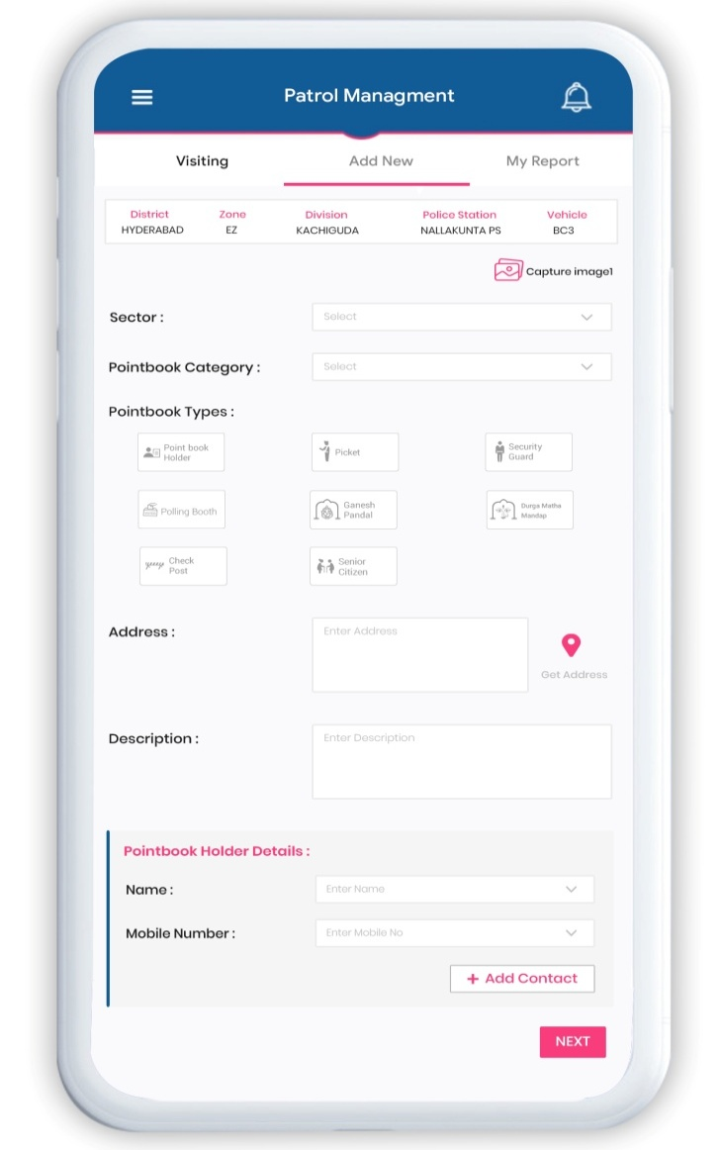
- Schedule PB Visit(PB Checking) timings for shift based Route plans:
This Task will be performed by SHO Role. In this module, The SHO has to assign the Route Plan to patrol car and blue colt officers, based on importance of point book (For Ex: based on school or Govt office timings, sensitivity etc). The Point book will be assigned with route timing to visit in Plan A, Plan B, Plan C & Plan D with shift based By SHO in web form, this job is scheduled for one time& later they can edit the timings depending the area situations. After scheduling the route plan details of the point books will be shown on PC APP with time for checking.

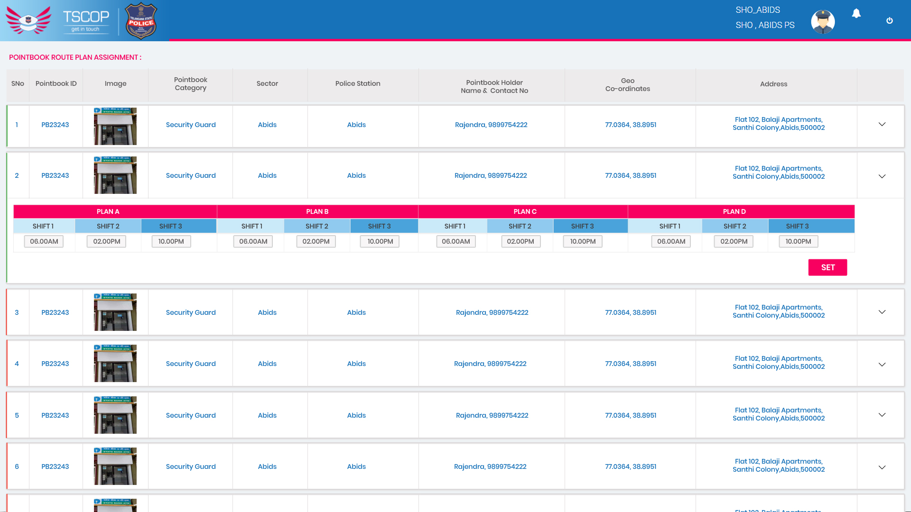

- Assigning a Daily Route Plan (SHO & District Admin & Police Control Rooms) :
This Task will be performed by SHO & District Admin & police Control room. This is daily task, where Admin will confirm today’s running Route plan (i.e. A, B, C, D etc). For example, In Police Station every point books are set with visit timings by SHO. When the control room confirm today’s running route plan based on shifts will help the police to operate in the Route plan also to monitor & surveillance the area. Necessity of daily schedule of route plan is, if police officer visits a particular Point book daily at the same time this may lead the criminals to take a chance to commit a crime. So with scheduling the route plans daily in different shifts, it will help the police to visit the area in undetectable pattern.
Fig 1: Control Room or District Admin Assign Route Plan Screen
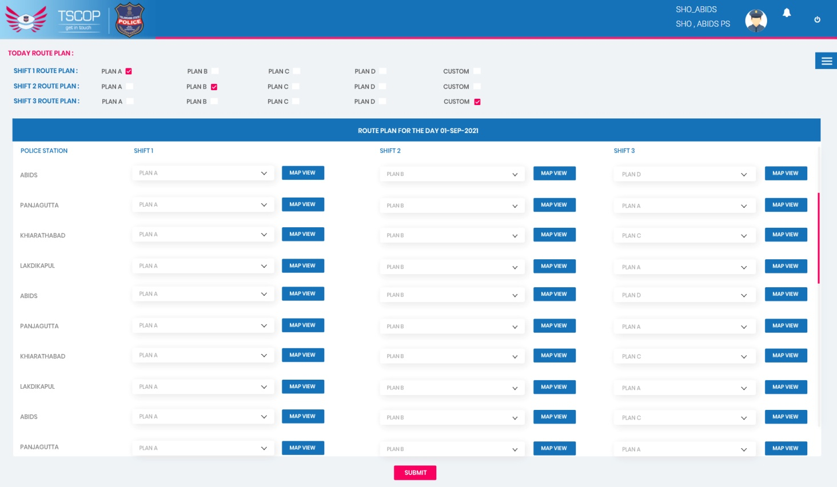
Fig 2: SHO Assign Route Plan Screen
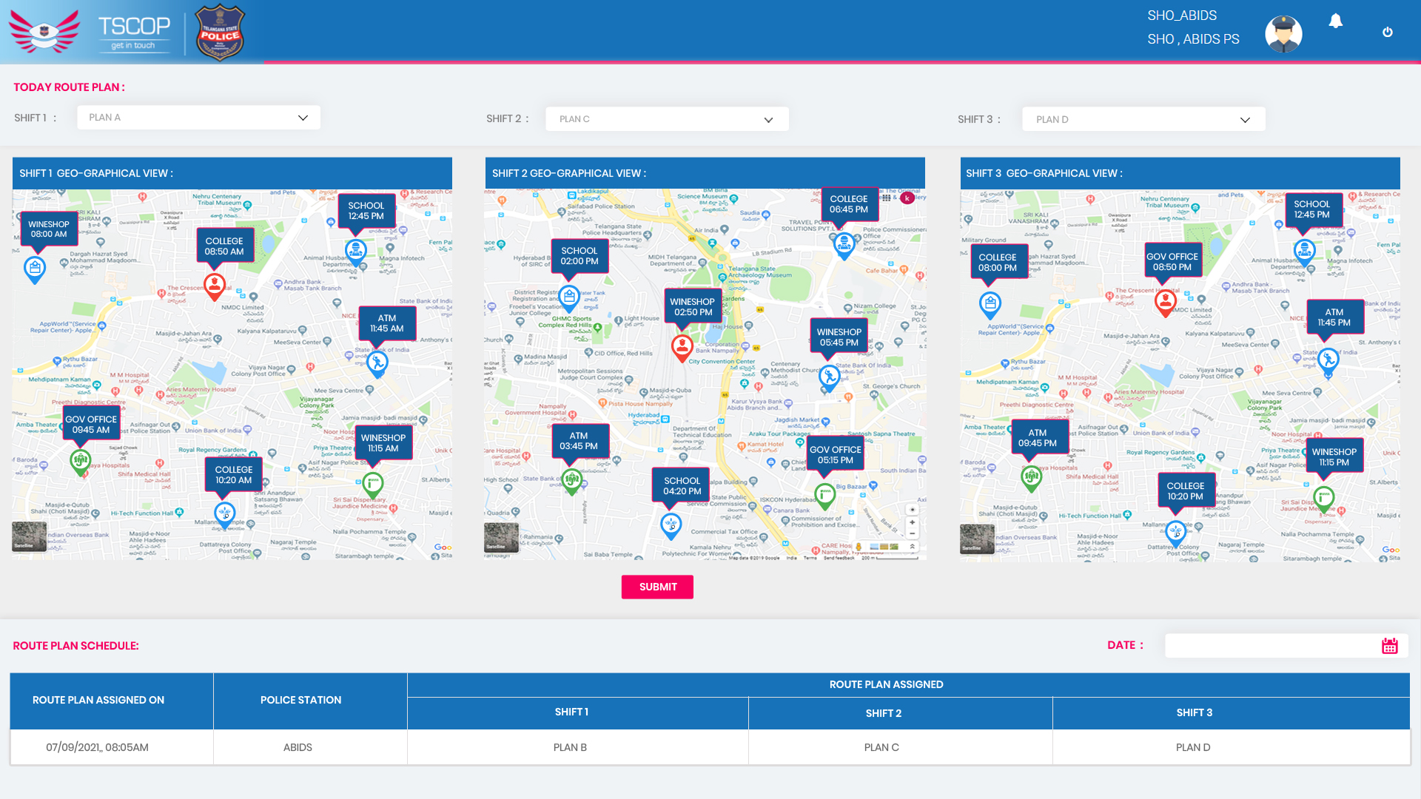

- Visiting a Point Book :
This Task will be performed by PC role. After got assigned with route plan for today, this plan will be visible on PC visiting APP Screen with timings. Where PC (Patrol Cars & blue colts) have to check the point book and update the status of the area.
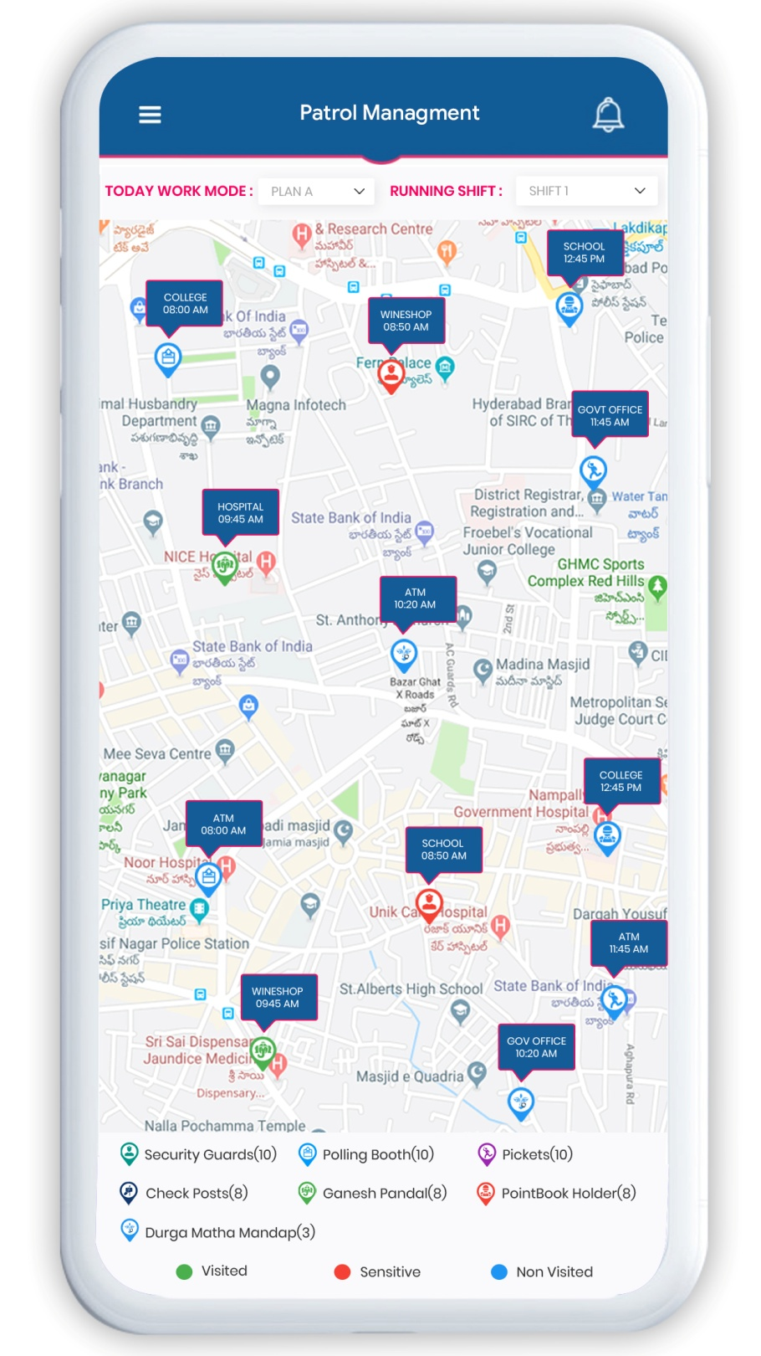

In the below screen while visiting, the deviation time is shown. Which means that SHO assigned a Time of visiting for point book while creating a Route plan when PC didn’t reach the point in the assigned time the deviation in time will increase which also gives the information like while travelling they may on job with emergency calls. In the TSCOP web reports, we will provide the statistical report like emergency calls handled during point book visiting and also with total deviation happened in between the process.
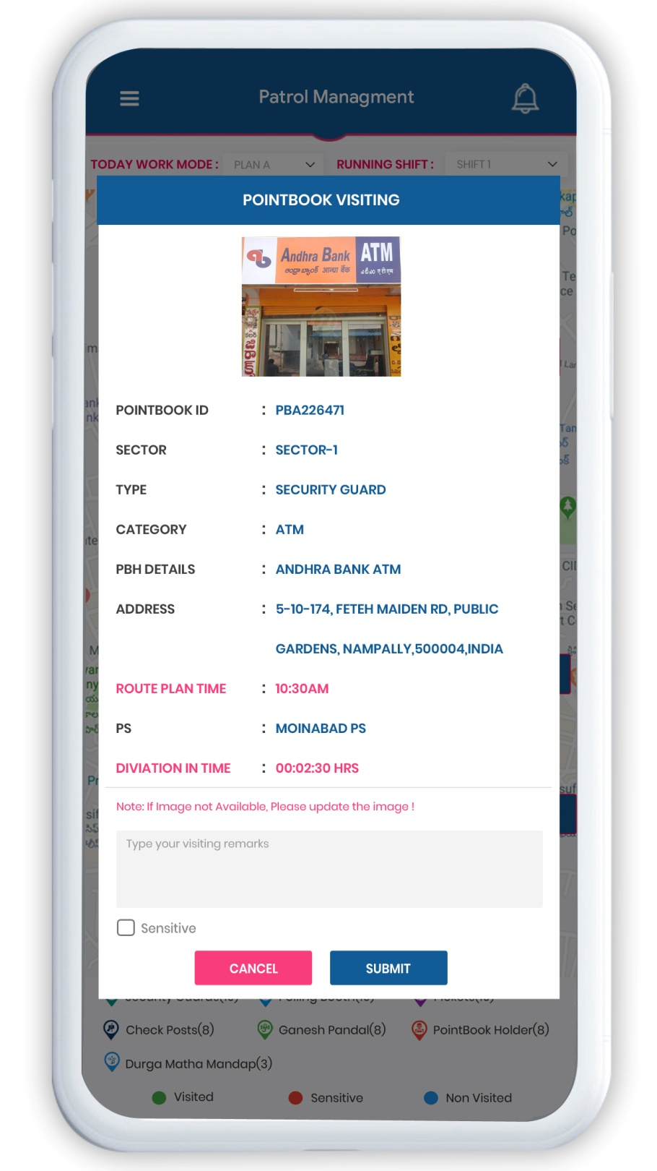

------------------------------------END----------------------------------------

